Internship Report
on
SMART CITY NETWORK SIMULATION AND TRAFFIC CONGESTION ANALYSIS

JAWAHARLAL NEHRU TECHNOLOGICAL UNIVERSITY ANANTAPUR, ANANTHAPURAMU

In Partial Fulfillment of the Requirements for the Award of the degree of

BACHELOR OF TECHNOLOGY
In
COMPUTER SCIENCE & ENGINEERING
Submitted By
D.MEGHANA - 24691A05KO



MADANAPALLE INSTITUTE OF TECHNOLOGY & SCIENCE
(UGC – AUTONOMOUS)
(Affiliated to JNTUA, Ananthapuram)
(Accredited by NBA, Approved by AICTE, New Delhi)
AN ISO 21001:2018 Certified Institution
P. B. No: 14, Angallu, Madanapalle – 517325

2026 - 27

DEPARTMENT OF COMPUTER SCIENCE & ENGINEERING

BONAFIDE CERTIFICATE

This is to certify that the internship work entitled” SMART CITY NETWORK SIMULATION AND TRAFFIC CONGESTION ANALYSIS” is a bonafide work carried out by

D.MEGHANA - 24691A05KO

Submitted in partial fulfillment of the requirements for the award of degree Bachelor of Technology in the stream of Computer Science & Engineering in Madanapalle Institute of Technology & Science, Madanapalle, affiliated to Jawaharlal Nehru Technological University Anantapur, Ananthapuramu during the academic year 2025-2026.

Internship Coordinator Head of the Department
Mr. Ch. Hemanand Dr. M. Sreedevi,
Assistant Professor, Professor & Head,
Department of CSE Department of CSE

Submitted for the University Examination held on:
Examiner:

ACKNOWLEDGEMENT

I sincerely thank the MANAGEMENT of Madanapalle Institute of Technology & Science for providing excellent infrastructure and lab facilities that helped me complete this Internship.

I sincerely thank Dr. P. Ramanathan, M.E., Ph.D., Principal, for guiding and providing facilities for completing our Internship at Madanapalle Institute of Technology & Science, Madanapalle.

I express our gratitude to Dr. Chandra Prakash Gupta, Ph.D., Professor and Dean-School of Computing for his continuous support in making necessary arrangements for the successful completion of the Internship.
I express our gratitude to Dr. M. Sreedevi, Ph.D., Professor and Head of the Department, CSE for her continuous support in making necessary arrangements for the successful completion of the Internship.
I express our sincere thanks to the Internship Coordinator, Mr. Ch. Hemanand, Assistant Professor, Department of CSE for his tremendous support for the successful completion of Internship.

I express our deep gratitude to our Internship In-Charge Ms. Sangeetha. M, Assistant Professor, Department of CSE, for his guidance and encouragement that helped us to complete this Internship.

I also wish to place on record my gratefulness to other Faculty of CSE Department and our friends and our parents for their help and cooperation during our project work.

DECLARATION

We hereby declare that the results embodied in this internship " SMART CITY NETWORK SIMULATION AND TRAFFIC CONGESTION ANALYSIS " by us under the guidance of Ms. Sangeetha. M, in partial fulfillment of the award of Bachelor of Technology in Computer Science & Engineering from Jawaharlal Nehru Technological University Anantapur, Ananthapuramu.

Date :

Place :

Internship Associate:

D.MEGHANA

ABSTRACT

Smart Cities require efficient communication networks and intelligent traffic management systems. This project, Smart City Network Simulation and Traffic Congestion Analysis, was developed using Cisco Packet Tracer, Python, and Flask. The network is divided into multiple VLANs representing different departments such as Traffic, Hospital, School, CCTV Monitoring, Public WiFi, and Management. Inter-VLAN communication is achieved using Router-on-a-Stick technology.
A Python-based congestion analysis system is used to monitor vehicle density and classify roads into Low, Medium, and High Congestion levels. A Flask Web Dashboard provides a simple interface for viewing traffic information and analysis results. The project demonstrates network segmentation, network security, traffic monitoring, CCTV surveillance, and smart city infrastructure management in an efficient and scalable manner.
Keywords: Smart City, Cisco Packet Tracer, VLAN, Router-on-a-Stick, Inter-VLAN Routing, Traffic Congestion Analysis, Python, Flask, CCTV Monitoring, Network Security.

CONTENTS

S.NO. | TOPIC | PAGE NO.
1 | INTRODUCTION
 | 1.1 About The Problem
 | 1.2 Importance and Applications
 | 1.3 Language used
 | 1.4 Need of the Model
2 | TOOLS AND TECHNIQUES
 | 2.1 Platform Used
 | 2.2 Hardware Requirements
 | 2.3 Software Requirements
3 | PROJECT WORK
 | 3.1 Overview Of The System
 | 3.2 Network Architecture
 | 3.3 Network Topology
 | 3.4 Vlan Configuration
 | 3.5 Router-On-a Stick Configuration
 | 3.6 CCTV Monitoring Network
 | 3.7 Public WIFI Network
 | 3.8 Traffic Configuration Analysis
 | 3.9 Flash web Dashboard
4 | OUTPUT SCREENSHOTS
5 | CONCLUSION

CHAPTER-1 INTRODUCTION

1.1 ABOUT THE PROBLEM
Modern cities face several challenges such as increasing traffic congestion, inefficient communication between departments, network security issues, and difficulties in monitoring city services. Different departments such as traffic management, hospitals, schools, and surveillance systems often require secure and organized communication. Without proper network segmentation, network traffic increases, security risks become higher, and overall management becomes difficult.
Another major challenge is traffic congestion, which affects transportation efficiency and public convenience. Monitoring traffic conditions manually is time-consuming and less effective. Therefore, there is a need for a system that can provide secure communication and basic traffic analysis within a smart city environment.

1.2 IMPORTANCE AND APPLICATIONS

Importance
- Provides secure communication between different city departments.
- Reduces unnecessary network traffic through VLAN segmentation.
- Improves network management and administration.
- Helps monitor traffic congestion levels.
- Supports efficient city operations and resource management.
- Demonstrates smart city concepts using networking and software technologies.

Applications
- Smart City Infrastructure Management
- Traffic Monitoring Systems
- CCTV Surveillance Networks
- Hospital Communication Networks
- Educational Institution Networks
- Public WiFi Management
- Government and Municipal Services
- Urban Planning and Development

1.3 LANGUAGES AND TECHNOLOGIES USED
The project was developed using the following languages and technologies:

Python: Python is used to develop the Traffic Congestion Analysis System. It processes vehicle data and categorizes roads into Low, Medium, and High congestion levels.

HTML: HTML is used to create the structure of the Flask web pages and dashboard interface.

CSS: CSS is used to improve the appearance and design of the web dashboard.

Flask: Flask is a Python web framework used to develop the traffic monitoring dashboard.

Cisco Packet Tracer: Cisco Packet Tracer is used to design and simulate the Smart City Network infrastructure.

Networking Technologies
- VLAN (Virtual Local Area Network)
- Inter-VLAN Routing
- Router-on-a-Stick
- DHCP Configuration
- IP Addressing

1.4 NEED OF THE MODEL (BRIEF EXPLANATION)
The Smart City Network Simulation and Traffic Congestion Analysis model is developed to demonstrate how networking and software technologies can be integrated to improve city management. The model provides a secure and organized network structure by dividing departments into separate VLANs and enabling communication through inter-VLAN routing.
The model also helps analyze traffic conditions using a Python-based congestion analysis system and displays the results through a Flask web dashboard. It serves as a simple and cost-effective solution for understanding smart city concepts, network security, traffic monitoring, and infrastructure management.
This model can be used for educational purposes, research activities, and as a foundation for developing more advanced smart city systems that incorporate IoT devices, real-time sensors, Artificial Intelligence (AI), and cloud computing technologies.

CHAPTER - 2
TOOLS AND TECHNIQUES

2.1 PLATFORM USED
The Smart City Network Simulation and Traffic Congestion Analysis project was developed using Cisco Packet Tracer, Python, and Flask. Cisco Packet Tracer was used to design and simulate the smart city network infrastructure, including VLAN configuration, inter-VLAN routing, and network connectivity. Python was used to develop the traffic congestion analysis system, while Flask was used to create a web-based dashboard for displaying traffic information and congestion status.
The project was developed and tested on a Windows operating system using Visual Studio Code as the development environment.

2.2 HARDWARE REQUIREMENTS
The following hardware components are required for the development and execution of the project:
S.No | Hardware Component | Specification
1 | Computer/Laptop | Intel i3 Processor or above
2 | RAM | Minimum 4 GB
3 | Storage | Minimum 500 MB Free Space
4 | Network Adapter | Ethernet/WiFi Enabled
5 | Display Monitor | Standard Monitor
6 | Internet Connection | Required for Software Installation

Simulated Network Devices
- Router
- Core Switch
- Traffic Department PCs
- Hospital Department PCs
- School Department PCs
- CCTV Monitoring PCs
- IP Cameras
- Public WiFi Router
- Management PC
- City Server

2.3 SOFTWARE REQUIREMENTS
The following software tools were used in the project:
S.No | Software | Purpose
1 | Cisco Packet Tracer | Network Design and Simulation
2 | Python 3.x | Traffic Congestion Analysis
3 | Flask | Web Dashboard Development
4 | Visual Studio Code | Code Development
5 | Web Browser | Accessing Flask Dashboard
6 | Windows 10/11 | Operating System

Technologies Used
- VLAN (Virtual Local Area Network)
- Router-on-a-Stick
- Inter-VLAN Routing
- DHCP
- IP Addressing
- Python Programming
- Flask Framework
- HTML
- CSS

CHAPTER – 3
SYSTEM DESIGN AND IMPLEMENTATION

3.1 OVERVIEW OF THE SYSTEM
The Smart City Network Simulation and Traffic Congestion Analysis system is designed to provide secure communication between different city departments and monitor traffic congestion levels. The network is divided into multiple VLANs representing various departments such as Traffic, Hospital, School, CCTV Monitoring, Public WiFi, and Management. Inter-VLAN communication is achieved using Router-on-a-Stick technology.
The project also includes a Python-based traffic congestion analysis module and a Flask web dashboard for displaying traffic information.
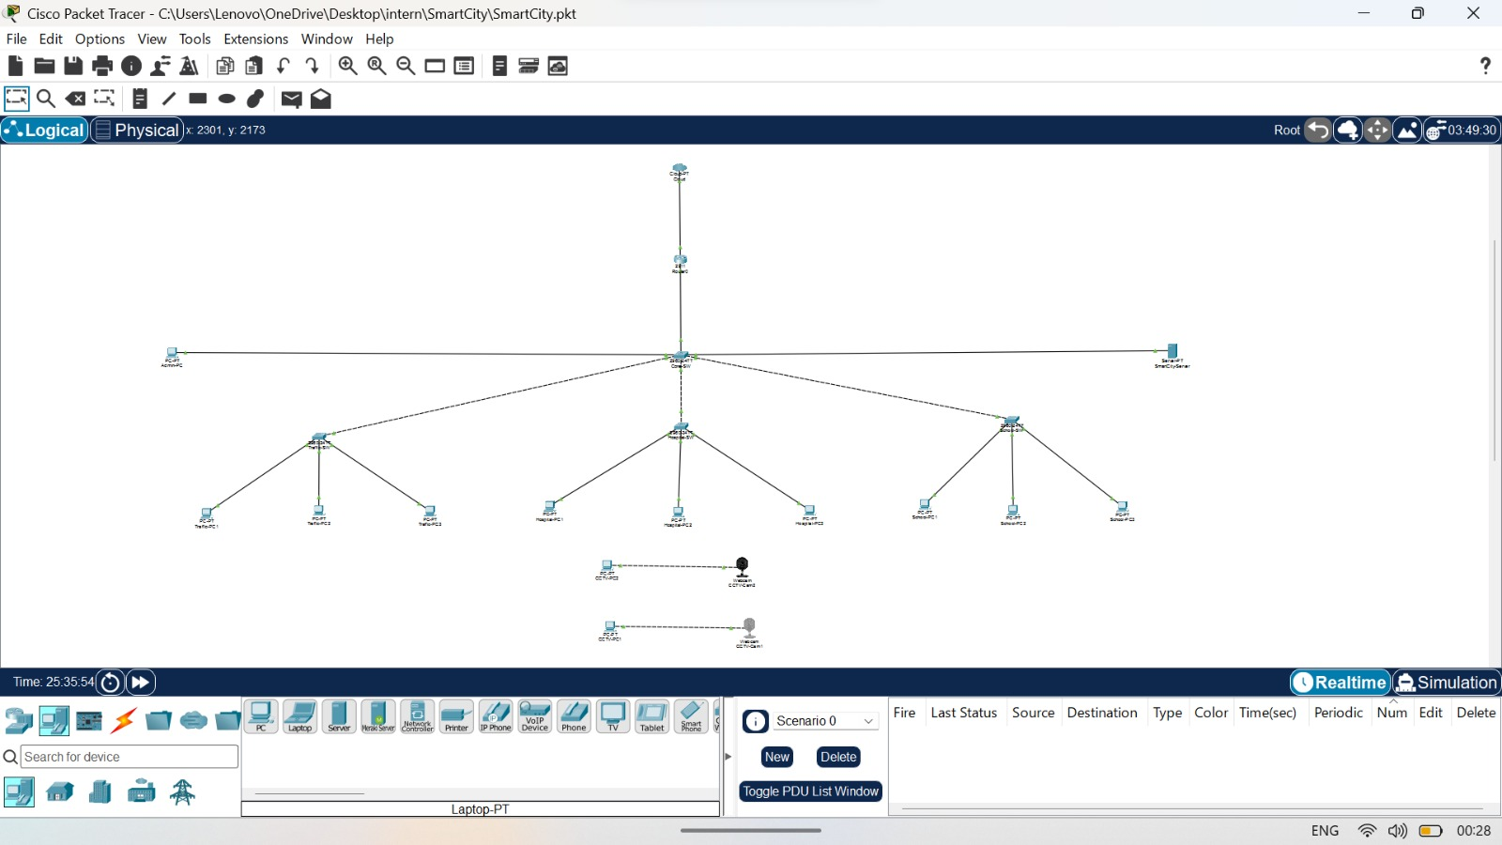
[Figure 3.1: Complete Smart City Network Topology Screenshot]

3.2 NETWORK ARCHITECTURE
The proposed network architecture consists of a Router, Core Switch, Departmental Switches, End Devices, IP Cameras, Public WiFi Router, Management PC, and City Server.
The Router performs inter-VLAN routing, while the Core Switch acts as the central connection point for all departmental networks.

Department-wise VLAN Structure

VLAN ID | Department
10 | Traffic Department
20 | Hospital Department
30 | School Department
40 | CCTV Monitoring
50 | Public WiFi
99 | Management

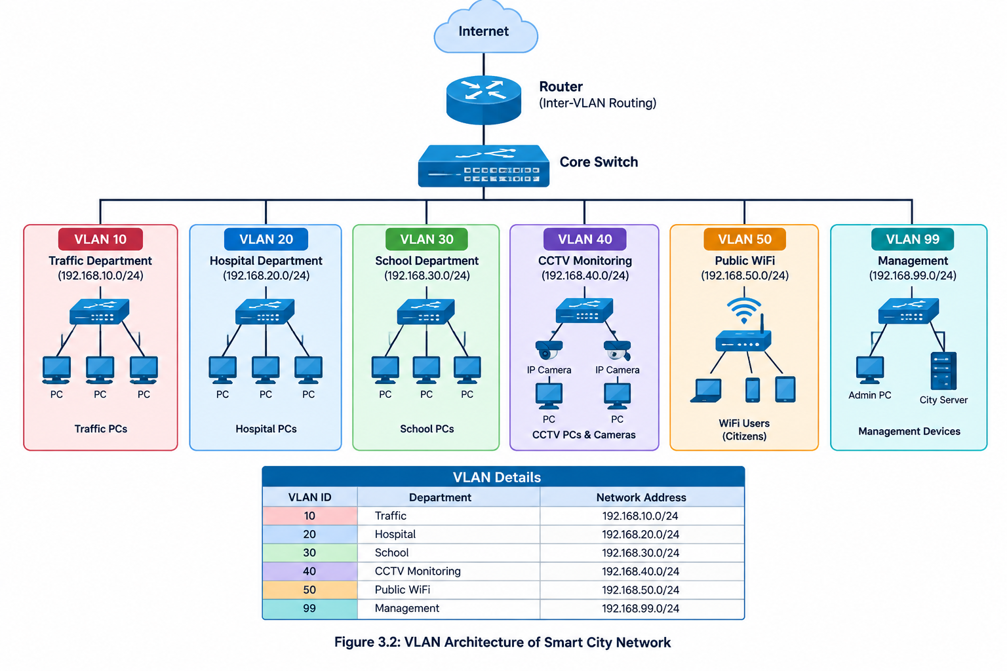

[Figure 3.2: VLAN Architecture Diagram]

3.3 NETWORK TOPOLOGY
The network topology follows a centralized architecture where all departmental switches are connected to the Core Switch. The Core Switch is connected to the Router for inter-VLAN communication and Internet access.
The topology includes:
- Traffic Department
- Hospital Department
- School Department
- CCTV Monitoring Center
- Public WiFi Network
- Management Network
- City Server

3.4. VLAN CONFIGURATION
VLANs are created to separate different departments and improve network security and performance.

VLAN Details
VLAN | Name | Network Address
10 | TRAFFIC | 192.168.10.0/24
20 | HOSPITAL | 192.168.20.0/24
30 | SCHOOL | 192.168.30.0/24
40 | CCTV | 192.168.40.0/24
50 | WIFI | 192.168.50.0/24
99 | MANAGEMENT | 192.168.99.0/24
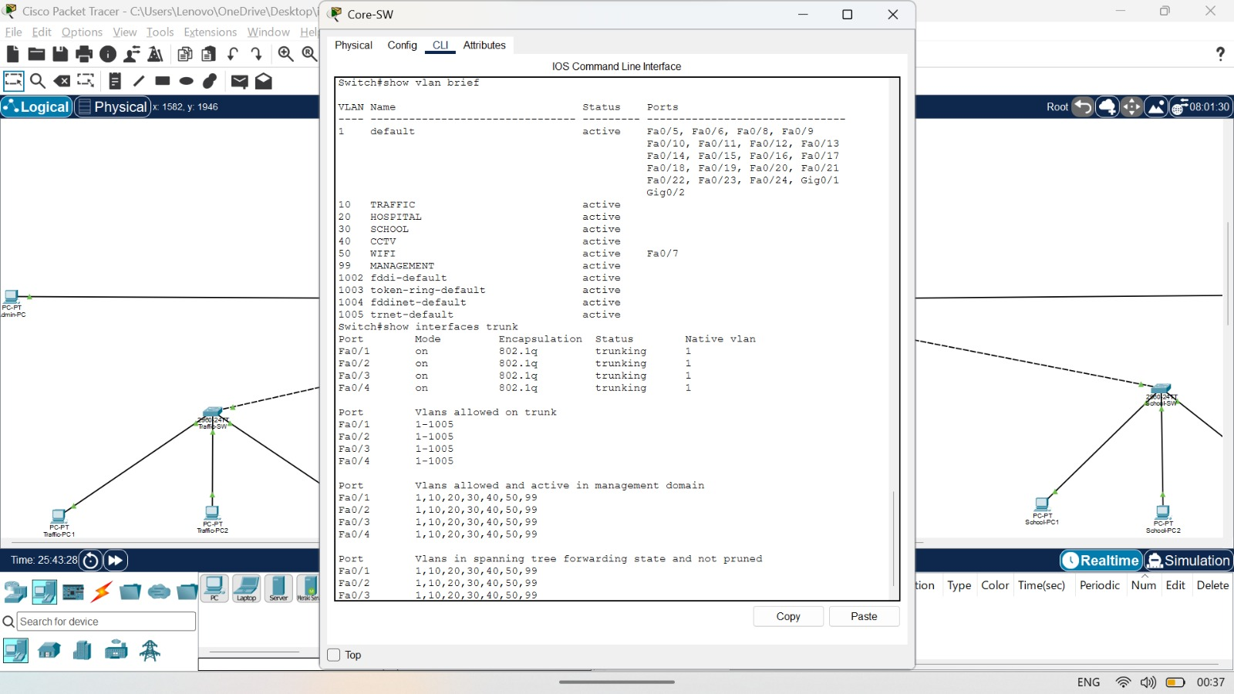
[Figure 3.4: VLAN Creation Screenshot]

Benefits of VLANs
- Improved Security
- Reduced Broadcast Traffic
- Better Network Management
- Department Isolation
- Easy Troubleshooting

3.5. ROUTER-ON-A-STICK CONFIGURATION
Router-on-a-Stick is used to enable communication between VLANs.
The Router contains multiple subinterfaces configured with IEEE 802.1Q encapsulation.

Router IP Configuration
Interface | IP Address
G0/1.10 | 192.168.10.1
G0/1.20 | 192.168.20.1
G0/1.30 | 192.168.30.1
G0/1.40 | 192.168.40.1
G0/1.50 | 192.168.50.1
G0/1.99 | 192.168.99.1
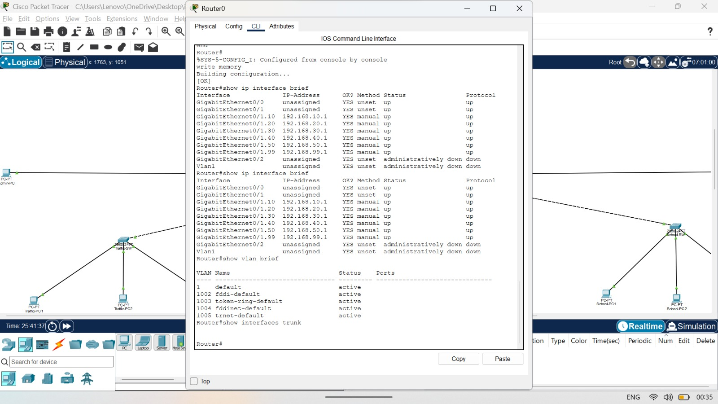[Figure 3.5.1: Router Configuration Screenshot]
[Figure 3.5.2: show ip interface brief Output]

3.6. CCTV MONITORING NETWORK
The CCTV Monitoring Network is implemented using VLAN 40. IP Cameras and CCTV Monitoring PCs are connected to the CCTV Switch.
The CCTV system provides surveillance capabilities for monitoring important city locations.

CCTV Devices
- CCTV-PC1
- CCTV-PC2
- IP Camera 1
- IP Camera 2

3.7. PUBLIC WIFI NETWORK
The Public WiFi network is implemented using VLAN 50 and a wireless router. Citizens can connect to the WiFi network and access Internet services.
Features:
- Wireless Connectivity
- Separate VLAN
- Secure Network Segmentation

3.8. TRAFFIC CONGESTION ANALYSIS
The traffic congestion analysis module is developed using Python.
Vehicle data is analyzed and categorized into:
- Low Congestion
- Medium Congestion
- High Congestion

Sample Results
Road Name | Vehicles | Status
Main Road | 120 | High
Hospital Road | 35 | Low
School Road | 90 | Medium
Market Road | 150 | High
Bus Station Road | 70 | Medium
Railway Road | 180 | High
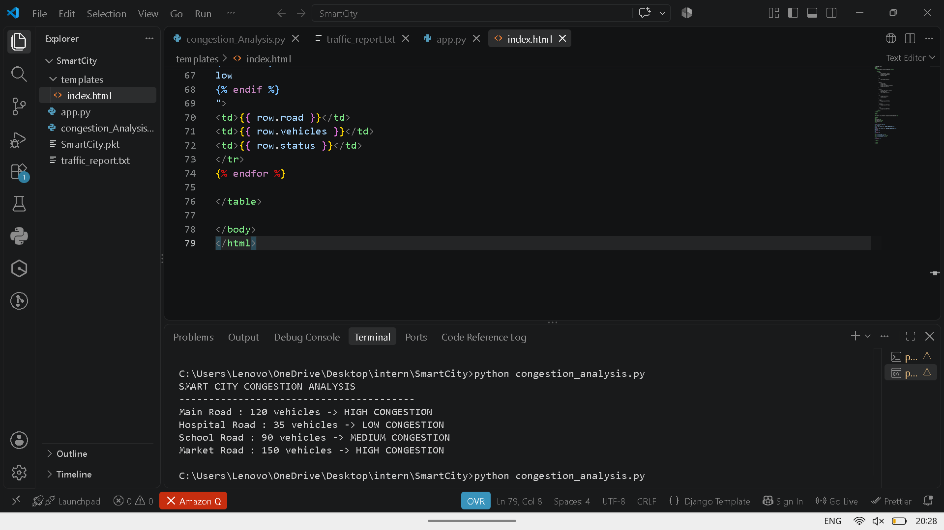
[Figure 3.8: Python Output Screenshot]

3.9. FLASK WEB DASHBOARD
The Flask dashboard provides a graphical interface for monitoring traffic information.
Features:
- Traffic Status Display
- Congestion Analysis
- User-Friendly Interface
- Real-Time Data Presentation
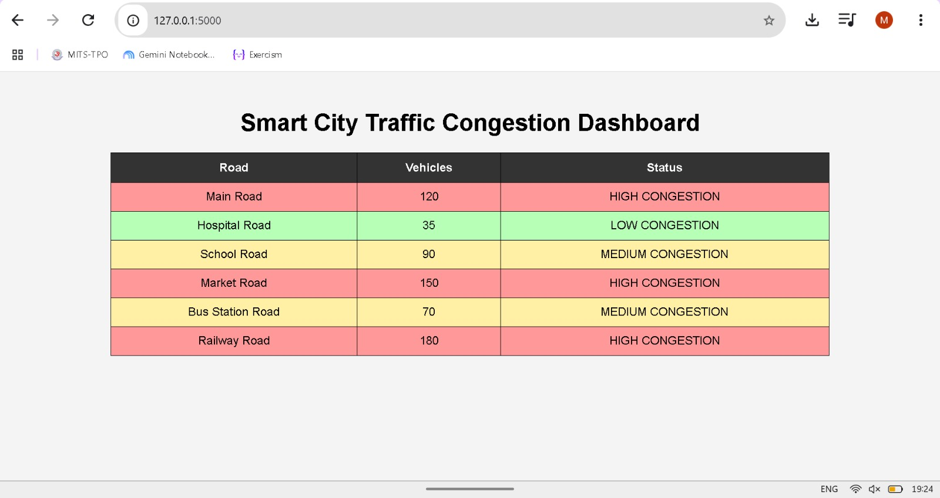
[Figure 3.9: Flask Dashboard Home Page]

CHAPTER – 4
OUTPUT SCREENSHOTS

4 Inter-VLAN Communication Testing
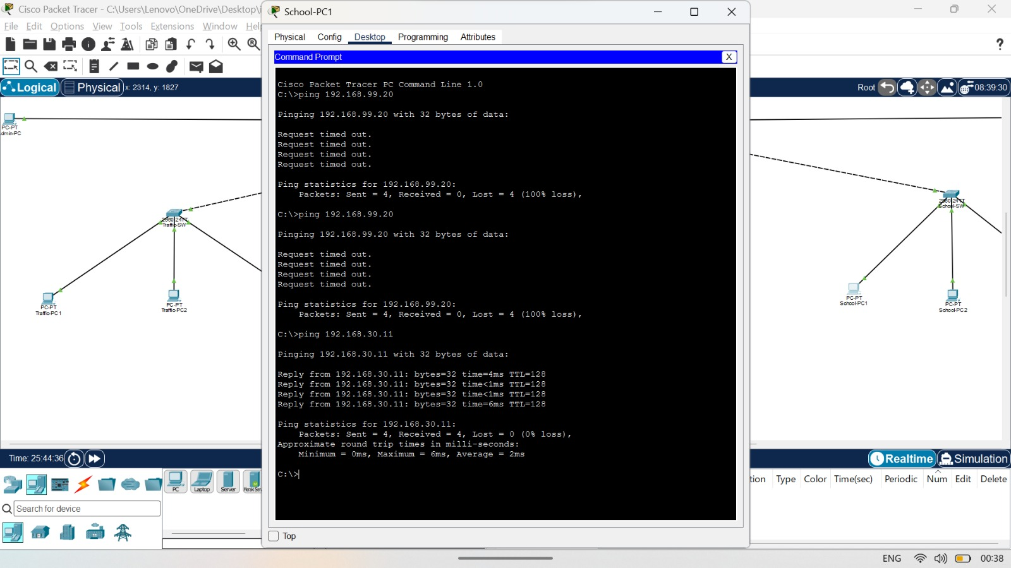
[Figure 4.1: School VLAN Connectivity Test]
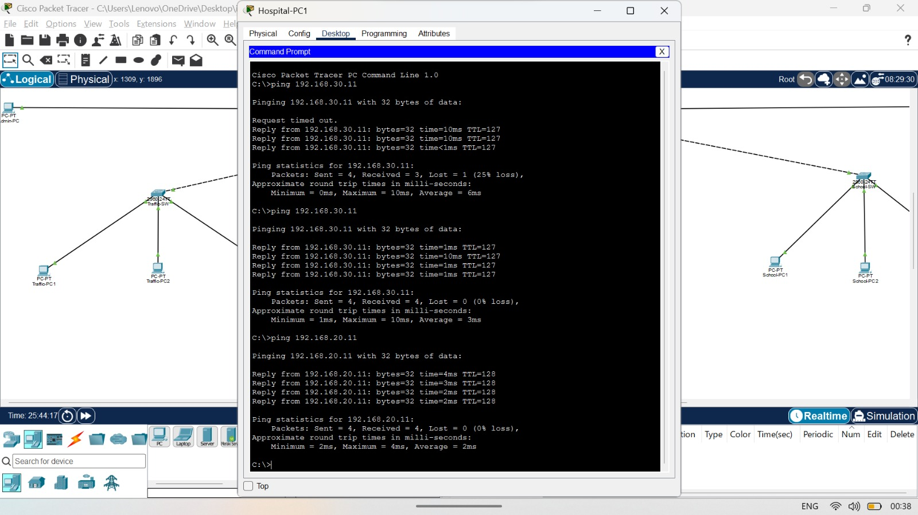
[Figure 4.2: Hospital VLAN Connectivity Test]
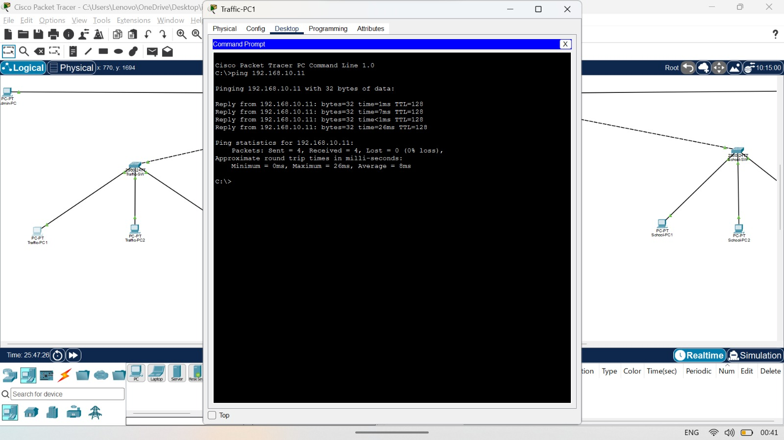
[Figure 4.3: Traffic VLAN Connectivity Test]

CHAPTER - 6
CONCLUSION

6.1 CONCLUSION
The Smart City Network Simulation and Traffic Congestion Analysis project was successfully designed and implemented using Cisco Packet Tracer, Python, and Flask. The network was divided into multiple VLANs, namely Traffic, Hospital, School, CCTV Monitoring, Public WiFi, and Management, to ensure efficient communication, security, and proper network management.
Inter-VLAN communication was achieved through Router-on-a-Stick technology, allowing devices from different departments to communicate successfully. Network testing using ping commands confirmed proper VLAN configuration, trunking, and routing functionality.
A Python-based traffic congestion analysis module was developed to classify traffic conditions into Low, Medium, and High congestion levels. The analyzed data was displayed through a Flask web dashboard, providing a simple and user-friendly interface for monitoring traffic conditions.
The project demonstrates how networking and software technologies can be integrated to support smart city infrastructure, improve communication between departments, and assist in traffic monitoring and management. Future enhancements may include real-time sensor integration, IoT-based traffic monitoring, cloud connectivity, and advanced analytics for smarter decision-making.

